

MySQL Assignment 2

FSE MySQL Assignment



September 4, 2018

Cognizant

Kolkata

Contents

**QUERY TO RETRIEVE THE BOOK AND ITS SUBJECT DETAILS USING INNER JOIN:** 1

**QUERY TO RETRIEVE THE BOOKS LIST PUBLISHED IN A GIVEN SPECIFIC DATE INTERVAL:** 2

**QUERY TO RETRIEVE THE NUMBER OF BOOKS REFERRED BY EACH SUBJECT WHERE THE SUBJECT TITE STARTS WITH A SPECIFIC CHARACTER:** 2

# **QUERY TO RETRIEVE THE BOOK AND ITS SUBJECT DETAILS USING INNER JOIN:**

SELECT b.BOOK_ID,

b.TITLE,

b.PRICE,

b.VOLUME,

b.PUBLISH_DATE,

b.SUBJECT_ID,

s.SUBTITLE,

s.DURATION_IN_HOURS

FROM BOOK b INNER JOIN SUBJECT s

ON b.SUBJECT_ID=s.SUBJECT_ID;

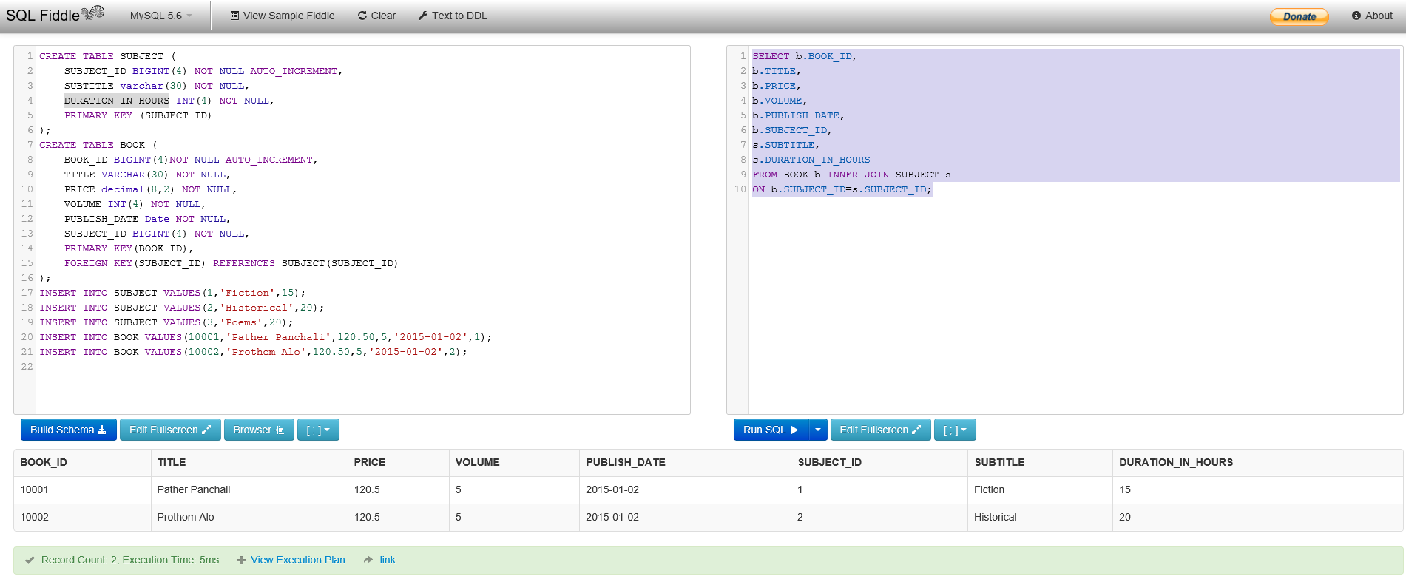

# **QUERY TO RETRIEVE THE BOOKS LIST PUBLISHED IN A GIVEN SPECIFIC DATE INTERVAL:**

SELECT * FROM BOOK

WHERE PUBLISH_DATE BETWEEN '2015-02-01' AND '2015-10-01';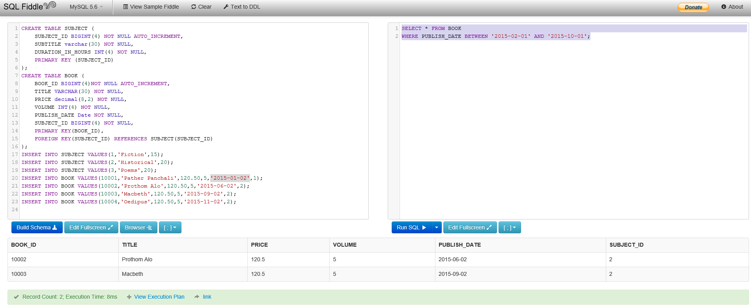

**QUERY TO RETRIEVE THE NUMBER OF BOOKS REFERRED BY EACH SUBJECT WHERE THE SUBJECT TITE STARTS WITH A SPECIFIC CHARACTER:**

SELECT *

FROM BOOK b inner join SUBJECT s

ON b.SUBJECT_ID=s.SUBJECT_ID

WHERE s.SUBTITLE LIKE 'H%';

